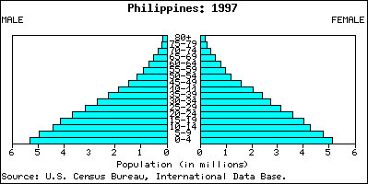

- Which age group has the highest number of males?

- How are the male and female population graphs different?

- What does the population pyramid tell us about the population?

- What are the implications, suggested by the population pyramid, on future government spending?
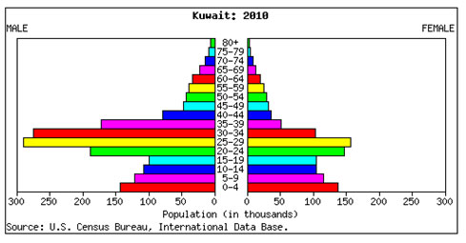

- Which age group has the highest percentage of females?

- How are the male and female population graphs different?

- Which age group has the highest percentage of males?

- Does this government need to spend more money on educating children or work programs? Explain your answer.

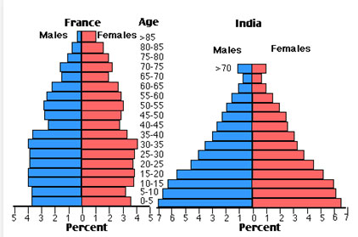

- What is the shape of the France pyramid?

- What is the shape of the India pyramid?

3. What does the difference in shapes say about the difference in population for each country?

- Which country should focus more on providing access to birth control for its citizens? Explain your answer.

Tying It All Together

You are the economic planner for one of the countries listed above (select The Philippines, Kuwait, France, or India). The president of your country has asked you to analyze that pyramid and determine the 5 vital services the country will need over the next 30 years. You will need to use all of your population pyramid analysis skills to provide information that the government can implement to ensure the comfort and safety of the country. Good Luck!

