Township and Range
TOWNSHIP measures the distance NORTH or SOUTH from the BASE LINE which is a designated parallel. A township USUALLY measures SIX MILES in size. The first six miles north of the base line is township one north written T. 1 N., running from 0 to 6 miles north of the base line. T. 4. S. would, therefore, be 18 to 24 miles south of the base line. RANGE measures EAST or WEST from the PRINCIPAL MERIDIAN which is a designated meridian. Ranges are also USUALLY SIX MILES in size. The first six miles west of the principal meridian would be range one west, R. 1 W.. R. 3 E. would be 12 to 18 miles east of the principal meridian. Each square, six miles by six miles is called a township.
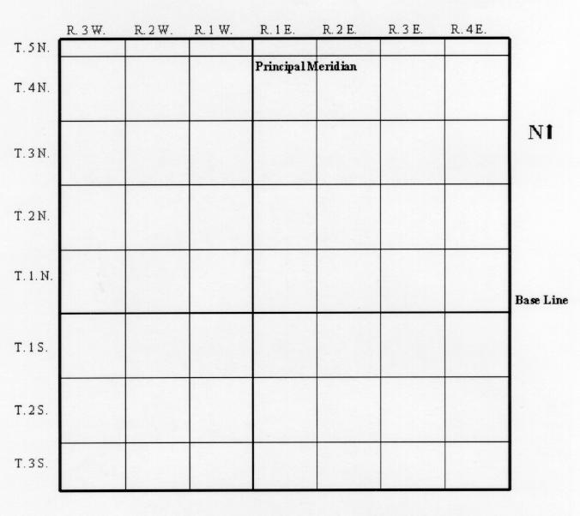
Townships are subdivided into SECTIONS. Since each township is six miles by six miles, township contains 36 square miles, each one forming a section. These are identified with a number based on their position. The northeasternmost section is section 1. They are numbered to the west in this northernmost row. The northwesternmost section in the township is section 6. Below it in the second row is section 7. This row is numbered toward the east. This snakelike pattern is continued so that the southwesternmost section is section 31 and the southeasternmost section is section 36. Note that to the east of section 36 will be section 31 of the next range but same township, and to the south of section 36 will be section 1 of the next township but the same range.
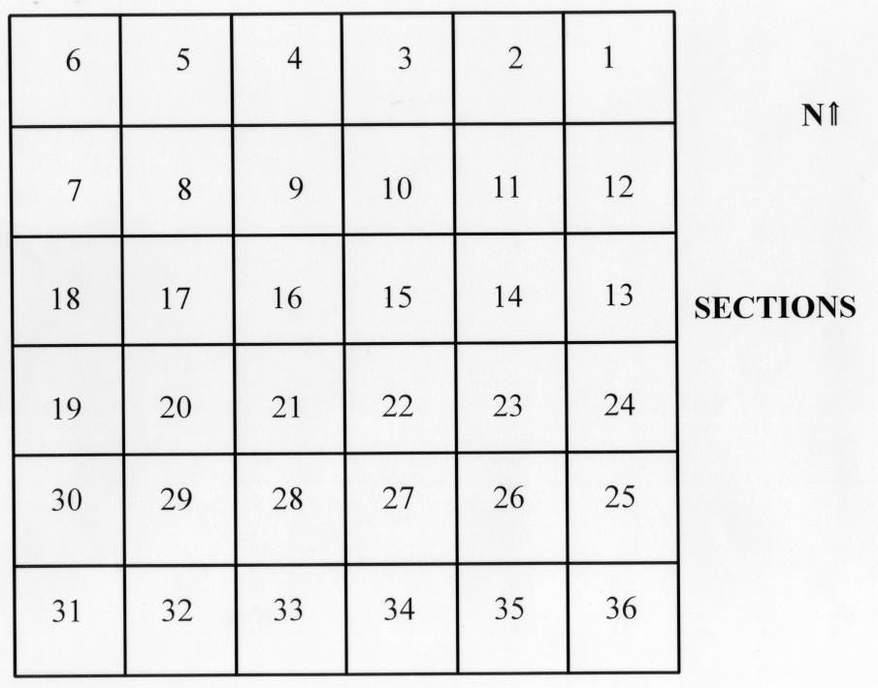
Sections are further divided into quarters. These are the northeast, northwest, southeast, and southwest quarters. Each of these usually contain 160 acres. These quarters are then further divided into quarters, which are then 40 acres. The smallest quarter is given followed by the largest quarter, then the section, and then the township and range. For example, the NE 1/4, SW 1/4, sec. 30. T. 5 S., R. 7 E. This is read as the northeast quarter of the southwest quarter of section thirty, township five south, range seven east.
